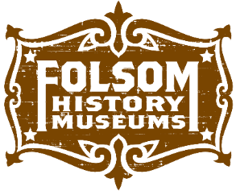
2018 TOUR REQUEST FORM
Folsom Historical Society
Today’s date: _________________
*Please allow a minimum of 2 -3 weeks advance notice for the tour date(s) you would like. This allows us time to customize the best tour to match your request. You will be contacted by phone or email within 3 business days of receiving this form. Thanks!
CONTACT INFORMATION
Primary Contact Name: _________________________________________________________________
School/Organization: ___________________________________________________________________
Phone: _____________________________________ Email: ____________________________________
REQUESTED TOUR DATE: _______________________________ TIME: ___________________________
Alternative Date (if applicable) __________________________ Alt. TIME: _________________________
Which tour/program are you interested in? Please circle below:
Folsom History Museum
Pioneer Village
Current Exhibit Gallery
3 OUTREACH PROGRAMS **(at your location- see below)
- Trails & Tales (story of Nancy Kelsey’s trip west)
- Mission Moments (daily life on a California mission)
- Songs of the Gold Rush (folk songs that reflect that era)

How many people are in your group?
Seniors ________________ Adults _________________ Youth______________
We recommend 1-8 adult-child ratio for on-site tours
Please return completed forms to either the Folsom History Museum front desk, or email them to education@folsomhistoricalsociety.org with the subject line: TOUR REQUEST.

