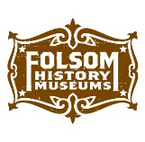
Field Trip/Outreach Request Form

Teacher’s Last Name | First Name
Contact Phone | Email
School/Group Name | Grade Level
School Address | Title 1 ☐ yes ☐ no  English Learners # ______

How many of each of the following will be attending? (Minimum 1 adult per 10 students)

Students (Minimum 10 Students) | Teacher/Instructional Asst. | Chaperones

We are interested in Docent-led Tours - $10/per student; $5/per chaperone; Teachers/IAs free (2 -3 hours)
☐ Folsom History Museum and Pioneer Village
☐ Folsom History Museum Only
☐ Pioneer Village Only

Requested Dates & Times for Program(s) for Docent-led Tours

Programs available from 9:30am-11:30 or 12:00pm-2:00pm
1st Preference | 2nd Preference | 3rd Preference
Date | Date | Date
Time | Time | Time

Will you be staying for lunch? (Historical era music performed during lunch) ☐ Yes ☐ No

Outreach Programs - $100 (We come to you – 1.5 hours)
☐ Nisenan Indian Children – Grade 3 ☐ Mission Moments – Grade 4
☐ Songs of the Gold Rush – Grade 4 ☐ I’ve Been Working on the Railroad – Grade 5
☐ Trails & Tales – Grade 3 - 5

Requested Dates & Times for Outreach Programs

Programs start at 9:00am
1st Preference | 2nd Preference | 3rd Preference
Date | Date | Date
Time | Time | Time

Would you like to pre-order souvenirs for your students? Items available for pre-order:
Vial of Gold  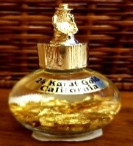 |  | Gemstones in Pouch  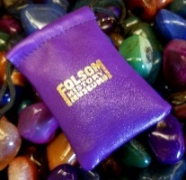 |  | Train Whistle  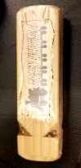 |  | Woven Bracelet  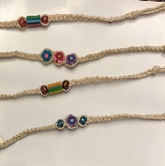 |  | Pony Express Map  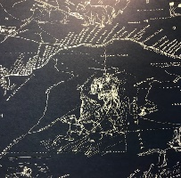 |  | Nugget Bubble Gum  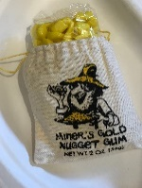
Price | How  Many? | Price | How  Many? | Price | How  Many? | Price | How  Many? | Price | How  Many? | Price | How  Many?
$8.99 |  | $3.95 |  | $4.50 |  | $1.95 |  | $5.00 |  | $3.75

We will do our best to accommodate your requested programs, dates and times. As we rely on volunteer docents, times and dates may vary. In the event of program changes, we will notify you as soon as possible. Once confirmed, you will receive a confirmation and invoice by email. Please allow one business week to receive a response to your schedule request. Request forms can be submitted via email, fax or by mail. Payment may be made by check, credit card or PayPal and is due one week prior to your program.

CANCELLATION POLICY- We require a 1-week notice to cancel or reschedule programming. We will not issue a refund for cancellation less than 1 week from the original field trip date unless extreme weather conditions prohibit your visit.

Educational Programs
Folsom History Museum
823 Sutter Street
Folsom, CA 95630

Karla Davis, Education Director
(916) 985-2707
mailto:education@folsomhistoricalsociety.org

Have you visited us before? ☐ Yes ☐ No
If no, how did you hear about our field trip opportunities?
☐ Word of Mouth ☐ Museum Website ☐ Personal Visit to the Museum ☐ Internet Search
If Internet, please specify where: _________________________________________________________________________

